# Data Structure - Depth First Traversal

Here we will discuss the techniques by using which, we can traverse all the vertices of the graph.

Traversal means visiting all the nodes of a graph. There are two standard methods by using which, we can traverse the graphs. Let’s discuss each one of them in detail.

1. Breadth First Search
2. Depth First Search

# Depth First Search (DFS) Algorithm

Depth first search (DFS) algorithm starts with the initial node of the graph G, and then goes to deeper and deeper until we find the goal node or the node which has no children. The algorithm, then backtracks from the dead end towards the most recent node that is yet to be completely unexplored.The data structure which is being used in DFS is stack.

## **Depth First Search Algorithm**

A standard DFS implementation puts each vertex of the graph into one of two categories:

1. Visited
2. Not Visited

The purpose of the algorithm is to mark each vertex as visited while avoiding cycles.

The DFS algorithm works as follows:

1. Start by putting any one of the graph's vertices on top of a stack.
2. Take the top item of the stack and add it to the visited list.
3. Create a list of that vertex's adjacent nodes. Add the ones which aren't in the visited list to the top of the stack.
4. Keep repeating steps 2 and 3 until the stack is empty.

## **Depth First Search Example**

Let's see how the Depth First Search algorithm works with an example. We use an undirected graph with 5 vertices.

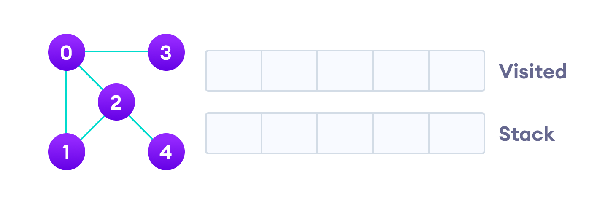Undirected graph with 5 vertices

We start from vertex 0, the DFS algorithm starts by putting it in the Visited list and putting all its adjacent vertices in the stack.

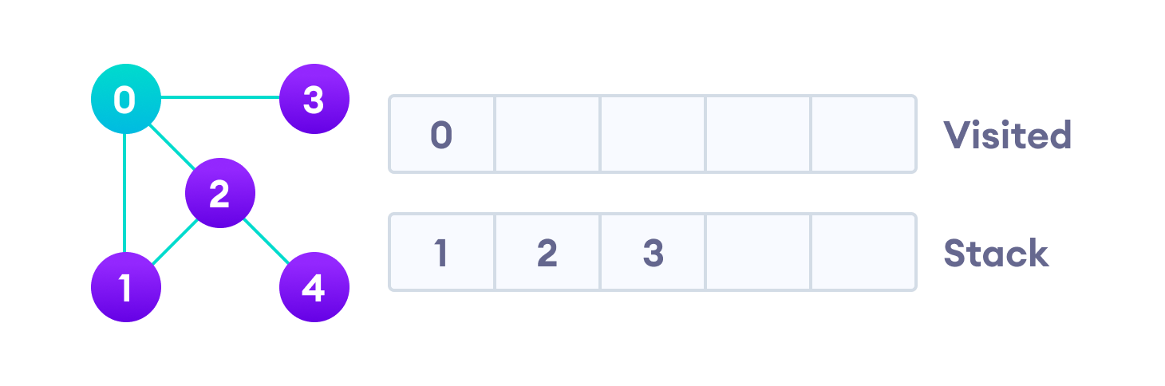Visit the element and put it in the visited list

Next, we visit the element at the top of stack i.e. 1 and go to its adjacent nodes. Since 0 has already been visited, we visit 2 instead.

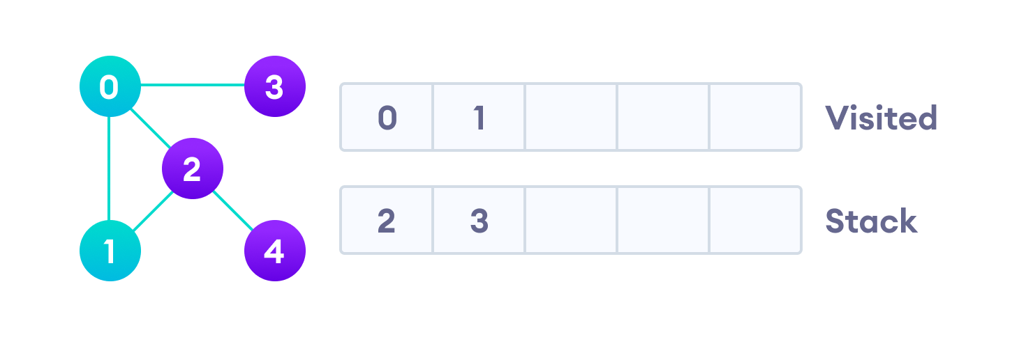Visit the element at the top of stack

Vertex 2 has an unvisited adjacent vertex in 4, so we add that to the top of the stack and visit it.

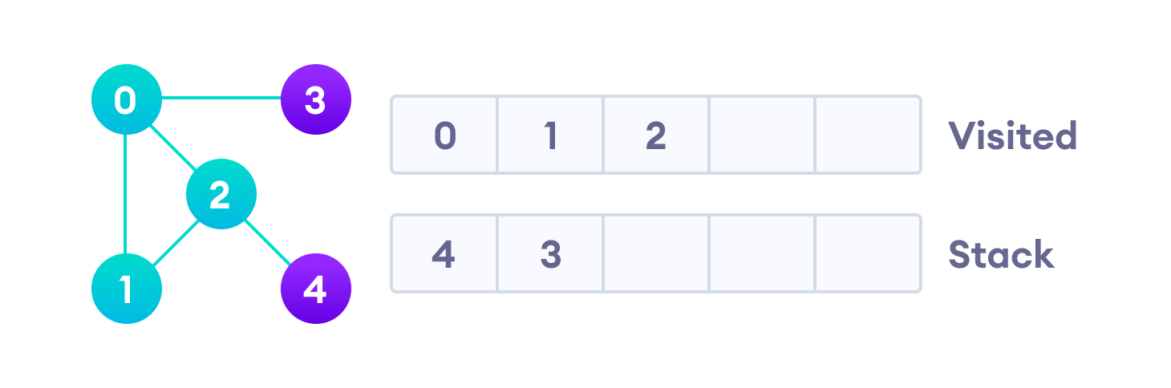Vertex 2 has an unvisited adjacent vertex in 4, so we add that to the top of the stack and visit it.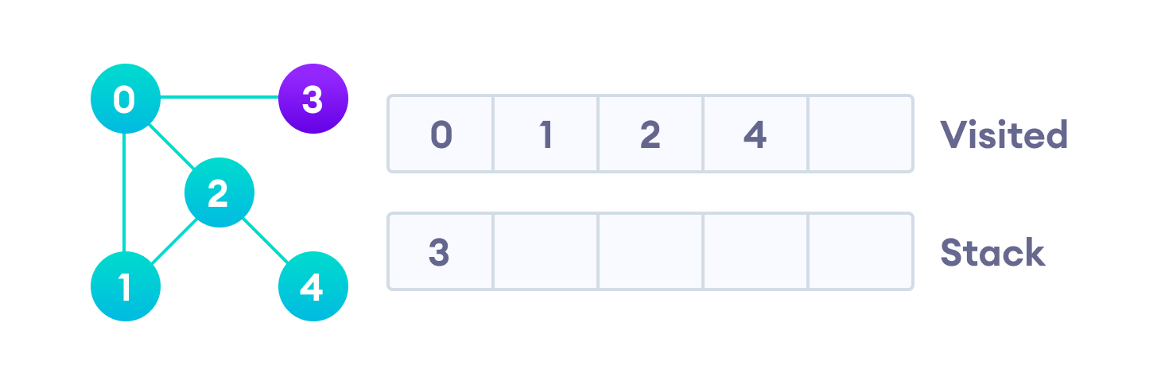Vertex 2 has an unvisited adjacent vertex in 4, so we add that to the top of the stack and visit it.

After we visit the last element 3, it doesn't have any unvisited adjacent nodes, so we have completed the Depth First Traversal of the graph.

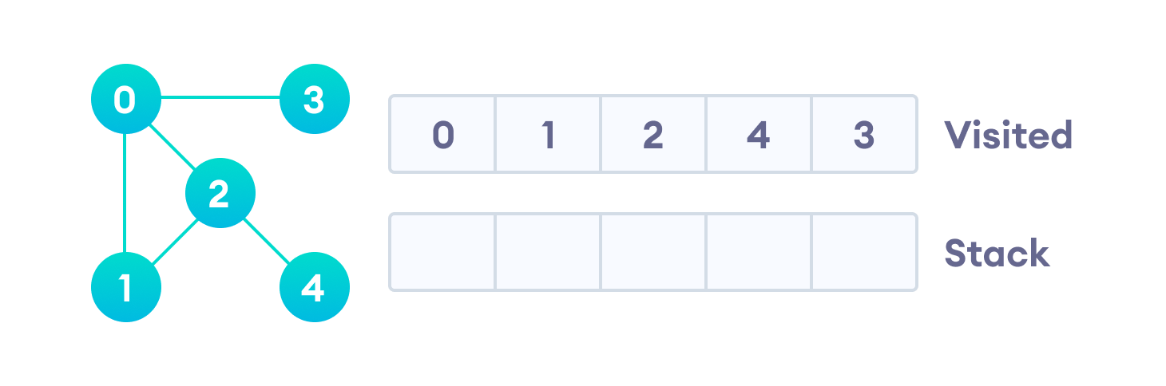After we visit the last element 3, it doesn't have any unvisited adjacent nodes, so we have completed the Depth First Traversal of the graph.

## **Complexity of Depth First Search**

The time complexity of the DFS algorithm is represented in the form of O(V + E), where V is the number of nodes and E is the number of edges.

The space complexity of the algorithm is O(V).

## **Application of DFS Algorithm**

1. For finding the path
2. To test if the graph is bipartite
3. For finding the strongly connected components of a graph
4. For detecting cycles in a graph